**Laporan Praktikum**

**Bahasa Pemrograman 1**

**Dosen pengampu : (*Dede Husen, M.Kom.*)**

# Modul 6



**Nama : Muhammad Rizal Nurfirdaus**

**NIM : 20230810088**

**Kelas : TINFC – 2023 – 04**

**Teknik Informatika Fakultas Ilmu Komputer**

**Universitas Kuningan**

**PreTest**

1. Apa itu database?

Database adalah kumpulan data yang terorganisir dan disimpan secara elektronik, biasanya dalam komputer, yang dapat diakses, dikelola, dan diperbarui dengan mudah. Database digunakan untuk menyimpan informasi yang terstruktur, seperti data pelanggan, inventaris, atau transaksi. Contohnya, MySQL, PostgreSQL, dan Microsoft SQL Server adalah beberapa sistem manajemen database yang populer.

1. Apa itu query?

Query adalah perintah atau instruksi yang digunakan untuk berinteraksi dengan database. Query memungkinkan pengguna untuk melakukan operasi seperti menambahkan, membaca, memperbarui, atau menghapus data di database. Dalam DBMS berbasis SQL (Structured Query Language), query menggunakan bahasa SQL untuk berkomunikasi dengan database.

1. Tuliskan Script koneksi untuk database bp1 dengan DBMS MySql

<?php

// Konfigurasi database

$host = "localhost"; // Nama host (default: localhost)

$username = "root"; // Username database

$password = ""; // Password database

$database = "bp1"; // Nama database

// Membuat koneksi

$koneksi = new mysqli($host, $username, $password, $database);

// Memeriksa koneksi

if ($koneksi->connect_error) {

die("Koneksi gagal: " . $koneksi->connect_error);

}

echo "Koneksi berhasil!";

?>

**Praktikum**



/*

* Click nbfs://nbhost/SystemFileSystem/Templates/Licenses/license-default.txt to change this license

* Click nbfs://nbhost/SystemFileSystem/Templates/Classes/Class.java to edit this template

*/

/**

*

* @author Muhammad Rizal Nur F

*/

import java.sql.Connection;

import java.sql.DriverManager;

import javax.swing.JOptionPane;

public class koneksi {

Connection con;

public koneksi(){

String id, pass, driver, url;

id = "root"; // user DBMS MySQL

pass = ""; // password DBMS MySQL

driver = "com.mysql.jdbc.Driver"; // driver MySQL

url = "jdbc:mysql://localhost:3306/db_mhs"; // nama database : db_mhs

try {

Class.forName(driver).newInstance();

con = DriverManager.getConnection(url, id, pass);

JOptionPane.showMessageDialog(null, "Koneksi Berhasil");

} catch (Exception e) {

System.out.println("" + e.getLocalizedMessage());

}

}

public static void main(String[] args) {

koneksi k= new koneksi(); // Nama kelas harus sesuai

}

}

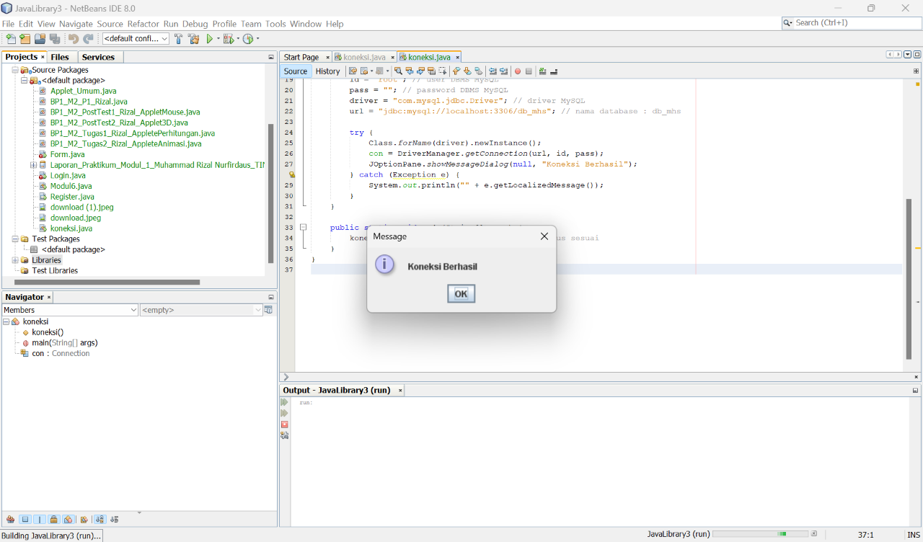



/*

* Click nbfs://nbhost/SystemFileSystem/Templates/Licenses/license-default.txt to change this license

* Click nbfs://nbhost/SystemFileSystem/Templates/GUIForms/JFrame.java to edit this template

*/

import java.sql.ResultSet;

import java.sql.Statement;

import javax.swing.JOptionPane;

import javax.swing.table.DefaultTableModel;

/**

*

* @author Muhammad Rizal Nurfirdaus

*/

public class Form extends javax.swing.JFrame {

Statement st;

ResultSet rs;

koneksi koneksi;

/**

* Creates new form form

*/

public Form() {

initComponents();

koneksi = new koneksi();

load_data();

}

private void load_data(){

Object header[]={"NIM", "Nama", "Jenis Kelamin", "Prodi", "Alamat"};

DefaultTableModel data = new DefaultTableModel(null, header);

jTable1.setModel(data);

String sql = "SELECT mhs.nim, mhs.nama, mhs.jk, mhs.prodi, mhs.alamat";

try{

st = koneksi.con.createStatement();

rs = st.executeQuery(sql);

while(rs.next()){

String k1 = rs.getString(1);

String k2 = rs.getString(2);

String k3 = rs.getString(3);

String k4 = rs.getString(4);

String k5 = rs.getString(5);

String k[]={k1,k2,k3,k4,k5};

data.addRow(k);

}

}catch(Exception e){

JOptionPane.showMessageDialog(null, e);

}

}

/**

* This method is called from within the constructor to initialize the form.

* WARNING: Do NOT modify this code. The content of this method is always

* regenerated by the Form Editor.

*/

@SuppressWarnings("unchecked")

// <editor-fold defaultstate="collapsed" desc="Generated Code">

private void initComponents() {

buttonGroup = new javax.swing.ButtonGroup();

jPanel1 = new javax.swing.JPanel();

jLabel1 = new javax.swing.JLabel();

jLabel2 = new javax.swing.JLabel();

jLabel3 = new javax.swing.JLabel();

jLabel4 = new javax.swing.JLabel();

jLabel5 = new javax.swing.JLabel();

jLabel6 = new javax.swing.JLabel();

jLabel7 = new javax.swing.JLabel();

jTextField1 = new javax.swing.JTextField();

jTextField2 = new javax.swing.JTextField();

jRadioButton1 = new javax.swing.JRadioButton();

jRadioButton2 = new javax.swing.JRadioButton();

jComboBox1 = new javax.swing.JComboBox<String>();

jScrollPane1 = new javax.swing.JScrollPane();

jTextArea1 = new javax.swing.JTextArea();

Simpan = new javax.swing.JToggleButton();

jScrollPane2 = new javax.swing.JScrollPane();

jTable1 = new javax.swing.JTable();

jLabel8 = new javax.swing.JLabel();

jLabel9 = new javax.swing.JLabel();

jLabel10 = new javax.swing.JLabel();

jLabel11 = new javax.swing.JLabel();

jTextField3 = new javax.swing.JTextField();

jTextField4 = new javax.swing.JTextField();

jTextField5 = new javax.swing.JTextField();

setDefaultCloseOperation(javax.swing.WindowConstants.EXIT_ON_CLOSE);

jLabel1.setText("DATA MAHASISWA");

jLabel2.setText("FORM INPUT DATA");

jLabel3.setText("Nama");

jLabel4.setText("NIM");

jLabel5.setText("Jenis Kelamin");

jLabel6.setText("Prodi");

jLabel7.setText("Alamat");

buttonGroup.add(jRadioButton1);

jRadioButton1.setText("L");

jRadioButton1.addActionListener(new java.awt.event.ActionListener() {

public void actionPerformed(java.awt.event.ActionEvent evt) {

jRadioButton1ActionPerformed(evt);

}

});

buttonGroup.add(jRadioButton2);

jRadioButton2.setText("P");

jComboBox1.setModel(new javax.swing.DefaultComboBoxModel(new String[] { "TI", "SI", "DKV", " " }));

jTextArea1.setColumns(20);

jTextArea1.setRows(5);

jScrollPane1.setViewportView(jTextArea1);

Simpan.setText("Simpan");

jTable1.setModel(new javax.swing.table.DefaultTableModel(

new Object [][] {

{null, null, null, null, null, null, null},

{null, null, null, null, null, null, null},

{null, null, null, null, null, null, null},

{null, null, null, null, null, null, null},

{null, null, null, null, null, null, null},

{null, null, null, null, null, null, null},

{null, null, null, null, null, null, null},

{null, null, null, null, null, null, null}

},

new String [] {

"Title 1", "Title 2", "Title 3", "Title 4", "Title 5", "Title 6", "Title 7"

}

));

jScrollPane2.setViewportView(jTable1);

jLabel8.setText("DATA MAHASISWA");

jLabel9.setText("Kelas");

jLabel10.setText("Angkatan");

jLabel11.setText("No HP");

javax.swing.GroupLayout jPanel1Layout = new javax.swing.GroupLayout(jPanel1);

jPanel1.setLayout(jPanel1Layout);

jPanel1Layout.setHorizontalGroup(

jPanel1Layout.createParallelGroup(javax.swing.GroupLayout.Alignment.LEADING)

.addGroup(jPanel1Layout.createSequentialGroup()

.addGroup(jPanel1Layout.createParallelGroup(javax.swing.GroupLayout.Alignment.LEADING)

.addGroup(jPanel1Layout.createSequentialGroup()

.addContainerGap()

.addGroup(jPanel1Layout.createParallelGroup(javax.swing.GroupLayout.Alignment.LEADING)

.addComponent(jLabel3)

.addComponent(jLabel6)

.addComponent(jLabel7)

.addComponent(jLabel9)

.addComponent(jLabel10)

.addComponent(jLabel11)

.addComponent(jLabel5)

.addComponent(jLabel4))

.addGap(65, 65, 65)

.addGroup(jPanel1Layout.createParallelGroup(javax.swing.GroupLayout.Alignment.LEADING)

.addGroup(jPanel1Layout.createSequentialGroup()

.addGroup(jPanel1Layout.createParallelGroup(javax.swing.GroupLayout.Alignment.LEADING)

.addComponent(Simpan)

.addGroup(jPanel1Layout.createParallelGroup(javax.swing.GroupLayout.Alignment.LEADING)

.addComponent(jScrollPane1, javax.swing.GroupLayout.Alignment.TRAILING, javax.swing.GroupLayout.PREFERRED_SIZE, javax.swing.GroupLayout.DEFAULT_SIZE, javax.swing.GroupLayout.PREFERRED_SIZE)

.addComponent(jComboBox1, javax.swing.GroupLayout.PREFERRED_SIZE, javax.swing.GroupLayout.DEFAULT_SIZE, javax.swing.GroupLayout.PREFERRED_SIZE))

.addGroup(jPanel1Layout.createSequentialGroup()

.addComponent(jRadioButton1)

.addPreferredGap(javax.swing.LayoutStyle.ComponentPlacement.RELATED)

.addComponent(jRadioButton2))

.addGroup(jPanel1Layout.createParallelGroup(javax.swing.GroupLayout.Alignment.TRAILING, false)

.addComponent(jTextField5, javax.swing.GroupLayout.Alignment.LEADING)

.addComponent(jTextField4, javax.swing.GroupLayout.Alignment.LEADING)

.addComponent(jTextField3, javax.swing.GroupLayout.Alignment.LEADING)

.addComponent(jTextField2, javax.swing.GroupLayout.Alignment.LEADING, javax.swing.GroupLayout.DEFAULT_SIZE, 207, Short.MAX_VALUE)

.addComponent(jTextField1, javax.swing.GroupLayout.Alignment.LEADING, javax.swing.GroupLayout.DEFAULT_SIZE, 207, Short.MAX_VALUE)))

.addGap(18, 18, 18)

.addComponent(jScrollPane2, javax.swing.GroupLayout.PREFERRED_SIZE, 564, javax.swing.GroupLayout.PREFERRED_SIZE))

.addGroup(jPanel1Layout.createSequentialGroup()

.addGap(21, 21, 21)

.addComponent(jLabel2)

.addGap(325, 325, 325)

.addComponent(jLabel8))))

.addGroup(jPanel1Layout.createSequentialGroup()

.addGap(342, 342, 342)

.addComponent(jLabel1)))

.addContainerGap(30, Short.MAX_VALUE))

);

jPanel1Layout.setVerticalGroup(

jPanel1Layout.createParallelGroup(javax.swing.GroupLayout.Alignment.LEADING)

.addGroup(jPanel1Layout.createSequentialGroup()

.addGap(18, 18, 18)

.addComponent(jLabel1)

.addGap(18, 18, 18)

.addGroup(jPanel1Layout.createParallelGroup(javax.swing.GroupLayout.Alignment.BASELINE)

.addComponent(jLabel2)

.addComponent(jLabel8))

.addPreferredGap(javax.swing.LayoutStyle.ComponentPlacement.UNRELATED)

.addGroup(jPanel1Layout.createParallelGroup(javax.swing.GroupLayout.Alignment.LEADING, false)

.addGroup(jPanel1Layout.createSequentialGroup()

.addGroup(jPanel1Layout.createParallelGroup(javax.swing.GroupLayout.Alignment.BASELINE)

.addComponent(jTextField1, javax.swing.GroupLayout.PREFERRED_SIZE, javax.swing.GroupLayout.DEFAULT_SIZE, javax.swing.GroupLayout.PREFERRED_SIZE)

.addComponent(jLabel4))

.addGap(18, 18, 18)

.addGroup(jPanel1Layout.createParallelGroup(javax.swing.GroupLayout.Alignment.BASELINE)

.addComponent(jTextField2, javax.swing.GroupLayout.PREFERRED_SIZE, javax.swing.GroupLayout.DEFAULT_SIZE, javax.swing.GroupLayout.PREFERRED_SIZE)

.addComponent(jLabel3))

.addGap(18, 18, 18)

.addGroup(jPanel1Layout.createParallelGroup(javax.swing.GroupLayout.Alignment.LEADING)

.addComponent(jLabel9)

.addComponent(jTextField3, javax.swing.GroupLayout.PREFERRED_SIZE, javax.swing.GroupLayout.DEFAULT_SIZE, javax.swing.GroupLayout.PREFERRED_SIZE))

.addGap(18, 18, 18)

.addGroup(jPanel1Layout.createParallelGroup(javax.swing.GroupLayout.Alignment.LEADING)

.addComponent(jLabel10)

.addComponent(jTextField4, javax.swing.GroupLayout.PREFERRED_SIZE, javax.swing.GroupLayout.DEFAULT_SIZE, javax.swing.GroupLayout.PREFERRED_SIZE))

.addGap(18, 18, 18)

.addGroup(jPanel1Layout.createParallelGroup(javax.swing.GroupLayout.Alignment.LEADING)

.addComponent(jLabel11)

.addComponent(jTextField5, javax.swing.GroupLayout.PREFERRED_SIZE, javax.swing.GroupLayout.DEFAULT_SIZE, javax.swing.GroupLayout.PREFERRED_SIZE))

.addGap(18, 18, 18)

.addGroup(jPanel1Layout.createParallelGroup(javax.swing.GroupLayout.Alignment.BASELINE)

.addComponent(jLabel5)

.addComponent(jRadioButton1)

.addComponent(jRadioButton2))

.addPreferredGap(javax.swing.LayoutStyle.ComponentPlacement.RELATED, javax.swing.GroupLayout.DEFAULT_SIZE, Short.MAX_VALUE)

.addGroup(jPanel1Layout.createParallelGroup(javax.swing.GroupLayout.Alignment.LEADING)

.addGroup(jPanel1Layout.createSequentialGroup()

.addComponent(jComboBox1, javax.swing.GroupLayout.PREFERRED_SIZE, javax.swing.GroupLayout.DEFAULT_SIZE, javax.swing.GroupLayout.PREFERRED_SIZE)

.addPreferredGap(javax.swing.LayoutStyle.ComponentPlacement.UNRELATED)

.addGroup(jPanel1Layout.createParallelGroup(javax.swing.GroupLayout.Alignment.LEADING)

.addComponent(jScrollPane1, javax.swing.GroupLayout.PREFERRED_SIZE, javax.swing.GroupLayout.DEFAULT_SIZE, javax.swing.GroupLayout.PREFERRED_SIZE)

.addComponent(jLabel7))

.addPreferredGap(javax.swing.LayoutStyle.ComponentPlacement.RELATED)

.addComponent(Simpan))

.addComponent(jLabel6)))

.addComponent(jScrollPane2, javax.swing.GroupLayout.PREFERRED_SIZE, 367, javax.swing.GroupLayout.PREFERRED_SIZE))

.addContainerGap(javax.swing.GroupLayout.DEFAULT_SIZE, Short.MAX_VALUE))

);

javax.swing.GroupLayout layout = new javax.swing.GroupLayout(getContentPane());

getContentPane().setLayout(layout);

layout.setHorizontalGroup(

layout.createParallelGroup(javax.swing.GroupLayout.Alignment.LEADING)

.addComponent(jPanel1, javax.swing.GroupLayout.DEFAULT_SIZE, javax.swing.GroupLayout.DEFAULT_SIZE, Short.MAX_VALUE)

);

layout.setVerticalGroup(

layout.createParallelGroup(javax.swing.GroupLayout.Alignment.LEADING)

.addComponent(jPanel1, javax.swing.GroupLayout.DEFAULT_SIZE, javax.swing.GroupLayout.DEFAULT_SIZE, Short.MAX_VALUE)

);

pack();

}// </editor-fold>

/**

* @param args the command line arguments

*/

public static void main(String args[]) {

/* Set the Nimbus look and feel */

//<editor-fold defaultstate="collapsed" desc=" Look and feel setting code (optional) ">

/* If Nimbus (introduced in Java SE 6) is not available, stay with the default look and feel.

* For details see http://download.oracle.com/javase/tutorial/uiswing/lookandfeel/plaf.html

*/

try {

for (javax.swing.UIManager.LookAndFeelInfo info : javax.swing.UIManager.getInstalledLookAndFeels()) {

if ("Nimbus".equals(info.getName())) {

javax.swing.UIManager.setLookAndFeel(info.getClassName());

break;

}

}

} catch (ClassNotFoundException ex) {

java.util.logging.Logger.getLogger(Form.class.getName()).log(java.util.logging.Level.SEVERE, null, ex);

} catch (InstantiationException ex) {

java.util.logging.Logger.getLogger(Form.class.getName()).log(java.util.logging.Level.SEVERE, null, ex);

} catch (IllegalAccessException ex) {

java.util.logging.Logger.getLogger(Form.class.getName()).log(java.util.logging.Level.SEVERE, null, ex);

} catch (javax.swing.UnsupportedLookAndFeelException ex) {

java.util.logging.Logger.getLogger(Form.class.getName()).log(java.util.logging.Level.SEVERE, null, ex);

}

//</editor-fold>

//</editor-fold>

/* Create and display the Form */

java.awt.EventQueue.invokeLater(new Runnable() {

public void run() {

new Form().setVisible(true);

}

});

}

// Variables declaration - do not modify

private javax.swing.JToggleButton Simpan;

private javax.swing.ButtonGroup buttonGroup;

private javax.swing.JComboBox<String> jComboBox1;

private javax.swing.JLabel jLabel1;

private javax.swing.JLabel jLabel10;

private javax.swing.JLabel jLabel11;

private javax.swing.JLabel jLabel2;

private javax.swing.JLabel jLabel3;

private javax.swing.JLabel jLabel4;

private javax.swing.JLabel jLabel5;

private javax.swing.JLabel jLabel6;

private javax.swing.JLabel jLabel7;

private javax.swing.JLabel jLabel8;

private javax.swing.JLabel jLabel9;

private javax.swing.JPanel jPanel1;

private javax.swing.JRadioButton jRadioButton1;

private javax.swing.JRadioButton jRadioButton2;

private javax.swing.JScrollPane jScrollPane1;

private javax.swing.JScrollPane jScrollPane2;

private javax.swing.JTable jTable1;

private javax.swing.JTextArea jTextArea1;

private javax.swing.JTextField jTextField1;

private javax.swing.JTextField jTextField2;

private javax.swing.JTextField jTextField3;

private javax.swing.JTextField jTextField4;

private javax.swing.JTextField jTextField5;

// End of variables declaration

}

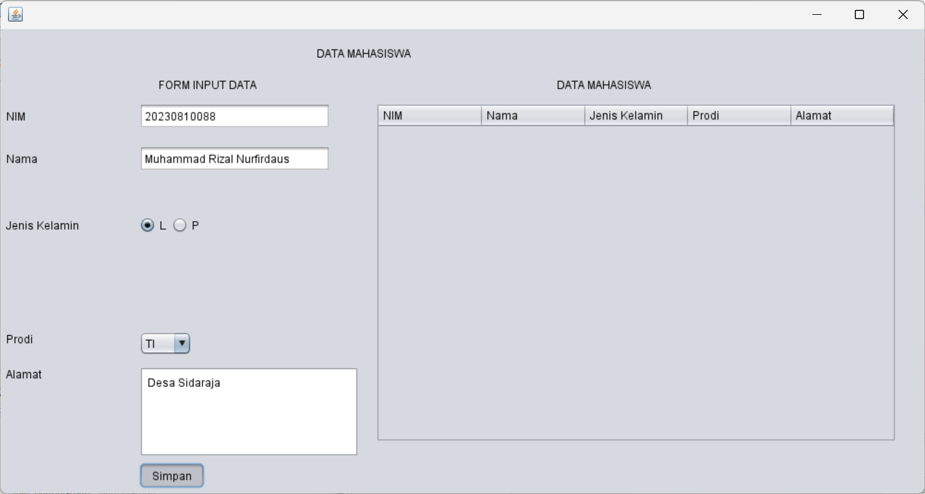

**PostTest**

1. Lengkapi Form Data Mahasiswa dengan menambahkan kelas, angkatan, dan no hp.

/*

* Click nbfs://nbhost/SystemFileSystem/Templates/Licenses/license-default.txt to change this license

* Click nbfs://nbhost/SystemFileSystem/Templates/GUIForms/JFrame.java to edit this template

*/

import java.sql.ResultSet;

import java.sql.Statement;

import javax.swing.JOptionPane;

import javax.swing.table.DefaultTableModel;

/**

*

* @author Muhammad Rizal Nurfirdaus

*/

public class Form extends javax.swing.JFrame {

Statement st;

ResultSet rs;

koneksi koneksi;

/**

* Creates new form form

*/

public Form() {

initComponents();

koneksi = new koneksi();

load_data();

}

private void simpan_data() {

String nim = jTextField1.getText();

String nama = jTextField2.getText();

String jk = jRadioButton1.isSelected() ? "L" : "P";

String prodi = (String) jComboBox1.getSelectedItem();

String alamat = jTextArea1.getText();

String sql = "INSERT INTO mhs (nim, nama, jk, prodi, alamat) VALUES ('" +

nim + "', '" + nama + "', '" + jk + "', '" + prodi + "', '" + alamat + "')";

try {

st = koneksi.con.createStatement();

st.executeUpdate(sql);

JOptionPane.showMessageDialog(null, "Data berhasil disimpan");

load_data(); // Memuat ulang tabel setelah menyimpan

} catch (Exception e) {

JOptionPane.showMessageDialog(null, "Gagal menyimpan data: " + e.getMessage());

}

}

private void load_data(){

Object header[]={"NIM", "Nama", "Jenis Kelamin", "Prodi", "Alamat"};

DefaultTableModel data = new DefaultTableModel(null, header);

jTable1.setModel(data);

String sql = "SELECT mhs.nim, mhs.nama, mhs.jk, mhs.prodi, mhs.alamat";

try{

st = koneksi.con.createStatement();

rs = st.executeQuery(sql);

while(rs.next()){

String k1 = rs.getString(1);

String k2 = rs.getString(2);

String k3 = rs.getString(3);

String k4 = rs.getString(4);

String k5 = rs.getString(5);

String k[]={k1,k2,k3,k4,k5};

data.addRow(k);

}

}catch(Exception e){

JOptionPane.showMessageDialog(null, e);

}

}

/**

* This method is called from within the constructor to initialize the form.

* WARNING: Do NOT modify this code. The content of this method is always

* regenerated by the Form Editor.

*/

@SuppressWarnings("unchecked")

// <editor-fold defaultstate="collapsed" desc="Generated Code">

private void initComponents() {

buttonGroup = new javax.swing.ButtonGroup();

jPanel1 = new javax.swing.JPanel();

jLabel1 = new javax.swing.JLabel();

jLabel2 = new javax.swing.JLabel();

jLabel3 = new javax.swing.JLabel();

jLabel4 = new javax.swing.JLabel();

jLabel5 = new javax.swing.JLabel();

jLabel6 = new javax.swing.JLabel();

jLabel7 = new javax.swing.JLabel();

jTextField1 = new javax.swing.JTextField();

jTextField2 = new javax.swing.JTextField();

jRadioButton1 = new javax.swing.JRadioButton();

jRadioButton2 = new javax.swing.JRadioButton();

jComboBox1 = new javax.swing.JComboBox<String>();

jScrollPane1 = new javax.swing.JScrollPane();

jTextArea1 = new javax.swing.JTextArea();

Simpan = new javax.swing.JToggleButton();

jScrollPane2 = new javax.swing.JScrollPane();

jTable1 = new javax.swing.JTable();

jLabel8 = new javax.swing.JLabel();

jLabel9 = new javax.swing.JLabel();

jLabel10 = new javax.swing.JLabel();

jLabel11 = new javax.swing.JLabel();

jTextField3 = new javax.swing.JTextField();

jTextField4 = new javax.swing.JTextField();

jTextField5 = new javax.swing.JTextField();

setDefaultCloseOperation(javax.swing.WindowConstants.EXIT_ON_CLOSE);

jLabel1.setText("DATA MAHASISWA");

jLabel2.setText("FORM INPUT DATA");

jLabel3.setText("Nama");

jLabel4.setText("NIM");

jLabel5.setText("Jenis Kelamin");

jLabel6.setText("Prodi");

jLabel7.setText("Alamat");

buttonGroup.add(jRadioButton1);

jRadioButton1.setText("L");

jRadioButton1.addActionListener(new java.awt.event.ActionListener() {

public void actionPerformed(java.awt.event.ActionEvent evt) {

// Define the method here or remove this call if not needed

}

});

buttonGroup.add(jRadioButton2);

jRadioButton2.setText("P");

jComboBox1.setModel(new javax.swing.DefaultComboBoxModel<>(new String[] { "TI", "SI", "DKV", " " }));

jTextArea1.setColumns(20);

jTextArea1.setRows(5);

jScrollPane1.setViewportView(jTextArea1);

Simpan.setText("Simpan");

Simpan.addActionListener(new java.awt.event.ActionListener() {

public void actionPerformed(java.awt.event.ActionEvent evt) {

simpan_data();

}

});

jTable1.setModel(new javax.swing.table.DefaultTableModel(

new Object [][] {

{null, null, null, null, null, null, null},

{null, null, null, null, null, null, null},

{null, null, null, null, null, null, null},

{null, null, null, null, null, null, null},

{null, null, null, null, null, null, null},

{null, null, null, null, null, null, null},

{null, null, null, null, null, null, null},

{null, null, null, null, null, null, null}

},

new String [] {

"Title 1", "Title 2", "Title 3", "Title 4", "Title 5", "Title 6", "Title 7"

}

));

jScrollPane2.setViewportView(jTable1);

jLabel8.setText("DATA MAHASISWA");

jLabel9.setText("Kelas");

jLabel10.setText("Angkatan");

jLabel11.setText("No HP");

javax.swing.GroupLayout jPanel1Layout = new javax.swing.GroupLayout(jPanel1);

jPanel1.setLayout(jPanel1Layout);

jPanel1Layout.setHorizontalGroup(

jPanel1Layout.createParallelGroup(javax.swing.GroupLayout.Alignment.LEADING)

.addGroup(jPanel1Layout.createSequentialGroup()

.addGroup(jPanel1Layout.createParallelGroup(javax.swing.GroupLayout.Alignment.LEADING)

.addGroup(jPanel1Layout.createSequentialGroup()

.addContainerGap()

.addGroup(jPanel1Layout.createParallelGroup(javax.swing.GroupLayout.Alignment.LEADING)

.addComponent(jLabel3)

.addComponent(jLabel6)

.addComponent(jLabel7)

.addComponent(jLabel9)

.addComponent(jLabel10)

.addComponent(jLabel11)

.addComponent(jLabel5)

.addComponent(jLabel4))

.addGap(65, 65, 65)

.addGroup(jPanel1Layout.createParallelGroup(javax.swing.GroupLayout.Alignment.LEADING)

.addGroup(jPanel1Layout.createSequentialGroup()

.addGroup(jPanel1Layout.createParallelGroup(javax.swing.GroupLayout.Alignment.LEADING)

.addComponent(Simpan)

.addGroup(jPanel1Layout.createParallelGroup(javax.swing.GroupLayout.Alignment.LEADING)

.addComponent(jScrollPane1, javax.swing.GroupLayout.Alignment.TRAILING, javax.swing.GroupLayout.PREFERRED_SIZE, javax.swing.GroupLayout.DEFAULT_SIZE, javax.swing.GroupLayout.PREFERRED_SIZE)

.addComponent(jComboBox1, javax.swing.GroupLayout.PREFERRED_SIZE, javax.swing.GroupLayout.DEFAULT_SIZE, javax.swing.GroupLayout.PREFERRED_SIZE))

.addGroup(jPanel1Layout.createSequentialGroup()

.addComponent(jRadioButton1)

.addPreferredGap(javax.swing.LayoutStyle.ComponentPlacement.RELATED)

.addComponent(jRadioButton2))

.addGroup(jPanel1Layout.createParallelGroup(javax.swing.GroupLayout.Alignment.TRAILING, false)

.addComponent(jTextField5, javax.swing.GroupLayout.Alignment.LEADING)

.addComponent(jTextField4, javax.swing.GroupLayout.Alignment.LEADING)

.addComponent(jTextField3, javax.swing.GroupLayout.Alignment.LEADING)

.addComponent(jTextField2, javax.swing.GroupLayout.Alignment.LEADING, javax.swing.GroupLayout.DEFAULT_SIZE, 207, Short.MAX_VALUE)

.addComponent(jTextField1, javax.swing.GroupLayout.Alignment.LEADING, javax.swing.GroupLayout.DEFAULT_SIZE, 207, Short.MAX_VALUE)))

.addGap(18, 18, 18)

.addComponent(jScrollPane2, javax.swing.GroupLayout.PREFERRED_SIZE, 564, javax.swing.GroupLayout.PREFERRED_SIZE))

.addGroup(jPanel1Layout.createSequentialGroup()

.addGap(21, 21, 21)

.addComponent(jLabel2)

.addGap(325, 325, 325)

.addComponent(jLabel8))))

.addGroup(jPanel1Layout.createSequentialGroup()

.addGap(342, 342, 342)

.addComponent(jLabel1)))

.addContainerGap(30, Short.MAX_VALUE))

);

jPanel1Layout.setVerticalGroup(

jPanel1Layout.createParallelGroup(javax.swing.GroupLayout.Alignment.LEADING)

.addGroup(jPanel1Layout.createSequentialGroup()

.addGap(18, 18, 18)

.addComponent(jLabel1)

.addGap(18, 18, 18)

.addGroup(jPanel1Layout.createParallelGroup(javax.swing.GroupLayout.Alignment.BASELINE)

.addComponent(jLabel2)

.addComponent(jLabel8))

.addPreferredGap(javax.swing.LayoutStyle.ComponentPlacement.UNRELATED)

.addGroup(jPanel1Layout.createParallelGroup(javax.swing.GroupLayout.Alignment.LEADING, false)

.addGroup(jPanel1Layout.createSequentialGroup()

.addGroup(jPanel1Layout.createParallelGroup(javax.swing.GroupLayout.Alignment.BASELINE)

.addComponent(jTextField1, javax.swing.GroupLayout.PREFERRED_SIZE, javax.swing.GroupLayout.DEFAULT_SIZE, javax.swing.GroupLayout.PREFERRED_SIZE)

.addComponent(jLabel4))

.addGap(18, 18, 18)

.addGroup(jPanel1Layout.createParallelGroup(javax.swing.GroupLayout.Alignment.BASELINE)

.addComponent(jTextField2, javax.swing.GroupLayout.PREFERRED_SIZE, javax.swing.GroupLayout.DEFAULT_SIZE, javax.swing.GroupLayout.PREFERRED_SIZE)

.addComponent(jLabel3))

.addGap(18, 18, 18)

.addGroup(jPanel1Layout.createParallelGroup(javax.swing.GroupLayout.Alignment.LEADING)

.addComponent(jLabel9)

.addComponent(jTextField3, javax.swing.GroupLayout.PREFERRED_SIZE, javax.swing.GroupLayout.DEFAULT_SIZE, javax.swing.GroupLayout.PREFERRED_SIZE))

.addGap(18, 18, 18)

.addGroup(jPanel1Layout.createParallelGroup(javax.swing.GroupLayout.Alignment.LEADING)

.addComponent(jLabel10)

.addComponent(jTextField4, javax.swing.GroupLayout.PREFERRED_SIZE, javax.swing.GroupLayout.DEFAULT_SIZE, javax.swing.GroupLayout.PREFERRED_SIZE))

.addGap(18, 18, 18)

.addGroup(jPanel1Layout.createParallelGroup(javax.swing.GroupLayout.Alignment.LEADING)

.addComponent(jLabel11)

.addComponent(jTextField5, javax.swing.GroupLayout.PREFERRED_SIZE, javax.swing.GroupLayout.DEFAULT_SIZE, javax.swing.GroupLayout.PREFERRED_SIZE))

.addGap(18, 18, 18)

.addGroup(jPanel1Layout.createParallelGroup(javax.swing.GroupLayout.Alignment.BASELINE)

.addComponent(jLabel5)

.addComponent(jRadioButton1)

.addComponent(jRadioButton2))

.addPreferredGap(javax.swing.LayoutStyle.ComponentPlacement.RELATED, javax.swing.GroupLayout.DEFAULT_SIZE, Short.MAX_VALUE)

.addGroup(jPanel1Layout.createParallelGroup(javax.swing.GroupLayout.Alignment.LEADING)

.addGroup(jPanel1Layout.createSequentialGroup()

.addComponent(jComboBox1, javax.swing.GroupLayout.PREFERRED_SIZE, javax.swing.GroupLayout.DEFAULT_SIZE, javax.swing.GroupLayout.PREFERRED_SIZE)

.addPreferredGap(javax.swing.LayoutStyle.ComponentPlacement.UNRELATED)

.addGroup(jPanel1Layout.createParallelGroup(javax.swing.GroupLayout.Alignment.LEADING)

.addComponent(jScrollPane1, javax.swing.GroupLayout.PREFERRED_SIZE, javax.swing.GroupLayout.DEFAULT_SIZE, javax.swing.GroupLayout.PREFERRED_SIZE)

.addComponent(jLabel7))

.addPreferredGap(javax.swing.LayoutStyle.ComponentPlacement.RELATED)

.addComponent(Simpan))

.addComponent(jLabel6)))

.addComponent(jScrollPane2, javax.swing.GroupLayout.PREFERRED_SIZE, 367, javax.swing.GroupLayout.PREFERRED_SIZE))

.addContainerGap(javax.swing.GroupLayout.DEFAULT_SIZE, Short.MAX_VALUE))

);

javax.swing.GroupLayout layout = new javax.swing.GroupLayout(getContentPane());

getContentPane().setLayout(layout);

layout.setHorizontalGroup(

layout.createParallelGroup(javax.swing.GroupLayout.Alignment.LEADING)

.addComponent(jPanel1, javax.swing.GroupLayout.DEFAULT_SIZE, javax.swing.GroupLayout.DEFAULT_SIZE, Short.MAX_VALUE)

);

layout.setVerticalGroup(

layout.createParallelGroup(javax.swing.GroupLayout.Alignment.LEADING)

.addComponent(jPanel1, javax.swing.GroupLayout.DEFAULT_SIZE, javax.swing.GroupLayout.DEFAULT_SIZE, Short.MAX_VALUE)

);

pack();

}// </editor-fold>

/**

* @param args the command line arguments

*/

public static void main(String args[]) {

/* Set the Nimbus look and feel */

//<editor-fold defaultstate="collapsed" desc=" Look and feel setting code (optional) ">

/* If Nimbus (introduced in Java SE 6) is not available, stay with the default look and feel.

* For details see http://download.oracle.com/javase/tutorial/uiswing/lookandfeel/plaf.html

*/

try {

for (javax.swing.UIManager.LookAndFeelInfo info : javax.swing.UIManager.getInstalledLookAndFeels()) {

if ("Nimbus".equals(info.getName())) {

javax.swing.UIManager.setLookAndFeel(info.getClassName());

break;

}

}

} catch (ClassNotFoundException ex) {

java.util.logging.Logger.getLogger(Form.class.getName()).log(java.util.logging.Level.SEVERE, null, ex);

} catch (InstantiationException ex) {

java.util.logging.Logger.getLogger(Form.class.getName()).log(java.util.logging.Level.SEVERE, null, ex);

} catch (IllegalAccessException ex) {

java.util.logging.Logger.getLogger(Form.class.getName()).log(java.util.logging.Level.SEVERE, null, ex);

} catch (javax.swing.UnsupportedLookAndFeelException ex) {

java.util.logging.Logger.getLogger(Form.class.getName()).log(java.util.logging.Level.SEVERE, null, ex);

}

//</editor-fold>

//</editor-fold>

/* Create and display the Form */

java.awt.EventQueue.invokeLater(new Runnable() {

public void run() {

new Form().setVisible(true);

}

});

}

// Variables declaration - do not modify

private javax.swing.JToggleButton Simpan;

private javax.swing.ButtonGroup buttonGroup;

private javax.swing.JComboBox<String> jComboBox1;

private javax.swing.JLabel jLabel1;

private javax.swing.JLabel jLabel10;

private javax.swing.JLabel jLabel11;

private javax.swing.JLabel jLabel2;

private javax.swing.JLabel jLabel3;

private javax.swing.JLabel jLabel4;

private javax.swing.JLabel jLabel5;

private javax.swing.JLabel jLabel6;

private javax.swing.JLabel jLabel7;

private javax.swing.JLabel jLabel8;

private javax.swing.JLabel jLabel9;

private javax.swing.JPanel jPanel1;

private javax.swing.JRadioButton jRadioButton1;

private javax.swing.JRadioButton jRadioButton2;

private javax.swing.JScrollPane jScrollPane1;

private javax.swing.JScrollPane jScrollPane2;

private javax.swing.JTable jTable1;

private javax.swing.JTextArea jTextArea1;

private javax.swing.JTextField jTextField1;

private javax.swing.JTextField jTextField2;

private javax.swing.JTextField jTextField3;

private javax.swing.JTextField jTextField4;

private javax.swing.JTextField jTextField5;

// End of variables declaration

}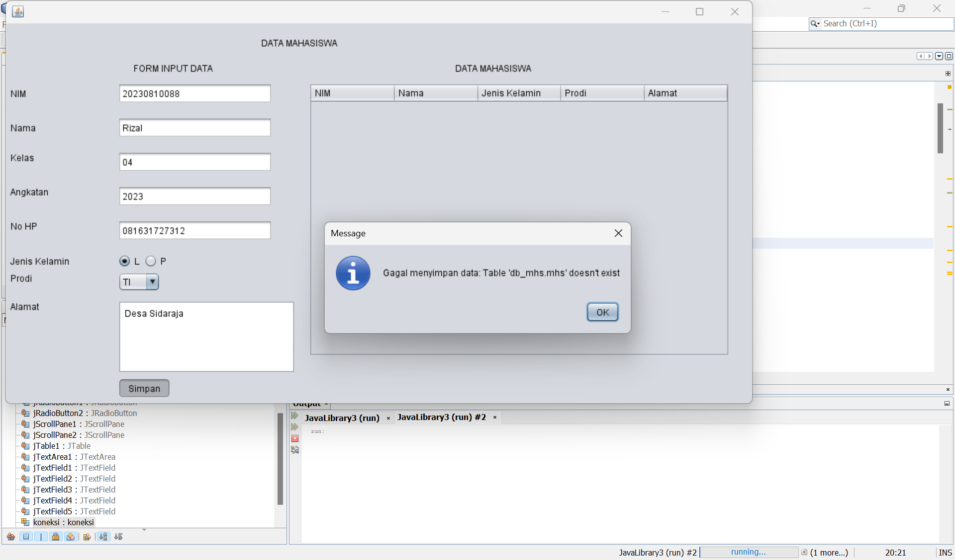

1. Lengkapi Database mahasiswa sesuai dengan penambahan pada no. 1.

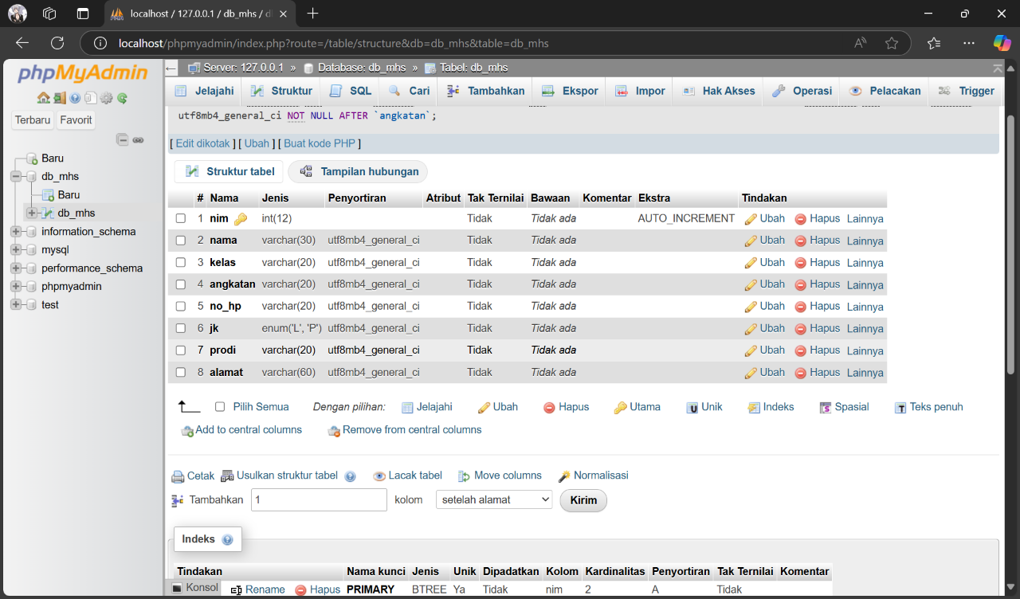

**Tugas**

1. Buat database admin (level terdiri dari admin dan user).

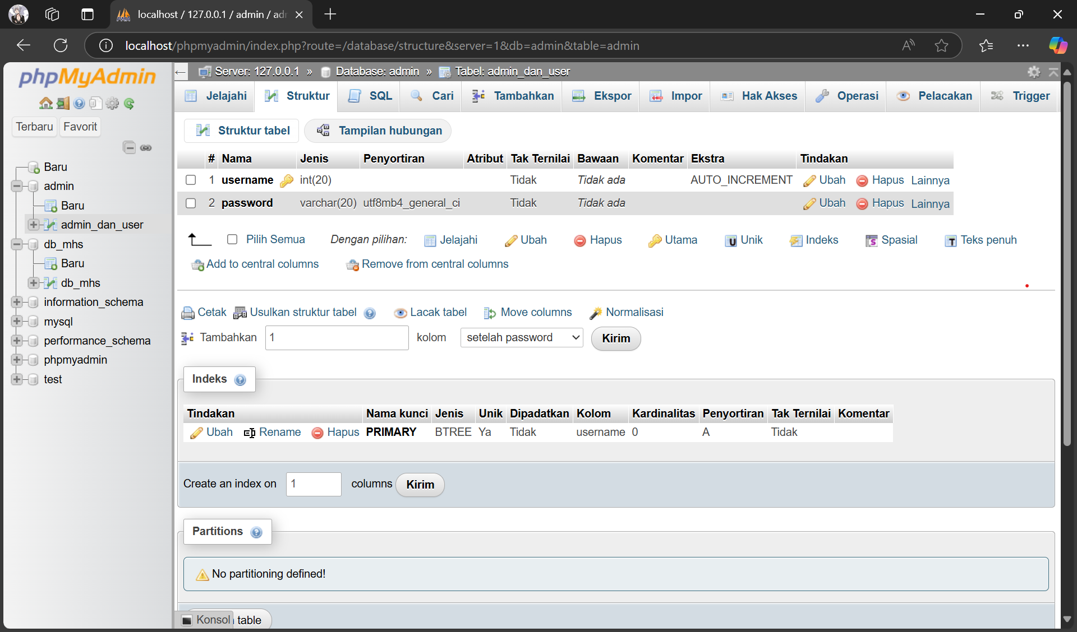

1. Koneksikan Form Login pada praktikum modul 4. Jika login berhasil, maka akan tampil Form Data Mahasiswa (praktikum modul 6).

/*

* Click nbfs://nbhost/SystemFileSystem/Templates/Licenses/license-default.txt to change this license

* Click nbfs://nbhost/SystemFileSystem/Templates/GUIForms/JFrame.java to edit this template

*/

import java.sql.ResultSet;

import java.sql.Statement;

import javax.swing.JOptionPane;

import java.sql.ResultSet;

import java.sql.Statement;

import javax.swing.JOptionPane;

import javax.swing.table.DefaultTableModel;

/**

*

* @author asephs

*/

public class Login extends javax.swing.JFrame {

Statement st;

ResultSet rs;

koneksi koneksi;

/**

* Creates new form Praktikum1

*/

public Login() {

initComponents();

koneksi = new koneksi();

}

/**

* This method is called from within the constructor to initialize the form.

* WARNING: Do NOT modify this code. The content of this method is always

* regenerated by the Form Editor.

*/

@SuppressWarnings("unchecked")

// <editor-fold defaultstate="collapsed" desc="Generated

// <editor-fold defaultstate="collapsed" desc="Generated

// <editor-fold defaultstate="collapsed" desc="Generated Code">

private void initComponents() {

jLabel1 = new javax.swing.JLabel();

jLabel2 = new javax.swing.JLabel();

jLabel3 = new javax.swing.JLabel();

jLabel4 = new javax.swing.JLabel();

jTextField1 = new javax.swing.JTextField();

jTextField2 = new javax.swing.JTextField();

jButton1 = new javax.swing.JButton();

jButton2 = new javax.swing.JButton();

jLabel5 = new javax.swing.JLabel();

jComboBox1 = new javax.swing.JComboBox<String>();

setDefaultCloseOperation(javax.swing.WindowConstants.EXIT_ON_CLOSE);

jLabel1.setFont(new java.awt.Font("Segoe UI", 1, 18)); // NOI18N

jLabel1.setText("Form Login");

jLabel2.setIcon(new javax.swing.ImageIcon(getClass().getResource("/com/mycompany/modul6/download (1).jpeg"))); // NOI18N

jLabel2.setText(" ");

jLabel3.setText("Username");

jLabel4.setText("Password");

jTextField2.addActionListener(new java.awt.event.ActionListener() {

public void actionPerformed(java.awt.event.ActionEvent evt) {

jTextField2ActionPerformed(evt);

}

});

jButton1.setText("LOGIN");

jButton1.addMouseListener(new java.awt.event.MouseAdapter() {

public void mouseClicked(java.awt.event.MouseEvent evt) {

jButton1MouseClicked(evt);

}

});

jButton1.addActionListener(new java.awt.event.ActionListener() {

public void actionPerformed(java.awt.event.ActionEvent evt) {

jButton1ActionPerformed(evt);

}

});

jButton2.setText("REGISTER");

jButton2.addActionListener(new java.awt.event.ActionListener() {

public void actionPerformed(java.awt.event.ActionEvent evt) {

jButton2ActionPerformed(evt);

}

});

jLabel5.setText("Level");

jComboBox1.setModel(new javax.swing.DefaultComboBoxModel(new String[] { "Admin", "User" }));

javax.swing.GroupLayout layout = new javax.swing.GroupLayout(getContentPane());

getContentPane().setLayout(layout);

layout.setHorizontalGroup(

layout.createParallelGroup(javax.swing.GroupLayout.Alignment.LEADING)

.addGroup(layout.createSequentialGroup()

.addContainerGap()

.addComponent(jLabel2)

.addPreferredGap(javax.swing.LayoutStyle.ComponentPlacement.UNRELATED)

.addGroup(layout.createParallelGroup(javax.swing.GroupLayout.Alignment.LEADING)

.addGroup(javax.swing.GroupLayout.Alignment.TRAILING, layout.createSequentialGroup()

.addComponent(jButton1)

.addPreferredGap(javax.swing.LayoutStyle.ComponentPlacement.RELATED, javax.swing.GroupLayout.DEFAULT_SIZE, Short.MAX_VALUE)

.addComponent(jButton2)

.addGap(28, 28, 28))

.addGroup(layout.createSequentialGroup()

.addGroup(layout.createParallelGroup(javax.swing.GroupLayout.Alignment.LEADING)

.addGroup(layout.createSequentialGroup()

.addGap(47, 47, 47)

.addComponent(jLabel1))

.addGroup(layout.createSequentialGroup()

.addGroup(layout.createParallelGroup(javax.swing.GroupLayout.Alignment.LEADING)

.addComponent(jLabel3)

.addComponent(jLabel4)

.addComponent(jLabel5))

.addGap(31, 31, 31)

.addGroup(layout.createParallelGroup(javax.swing.GroupLayout.Alignment.LEADING)

.addComponent(jComboBox1, javax.swing.GroupLayout.PREFERRED_SIZE, javax.swing.GroupLayout.DEFAULT_SIZE, javax.swing.GroupLayout.PREFERRED_SIZE)

.addGroup(layout.createParallelGroup(javax.swing.GroupLayout.Alignment.LEADING, false)

.addComponent(jTextField1, javax.swing.GroupLayout.DEFAULT_SIZE, 120, Short.MAX_VALUE)

.addComponent(jTextField2)))))

.addContainerGap(javax.swing.GroupLayout.DEFAULT_SIZE, Short.MAX_VALUE))))

);

layout.setVerticalGroup(

layout.createParallelGroup(javax.swing.GroupLayout.Alignment.LEADING)

.addGroup(layout.createSequentialGroup()

.addComponent(jLabel1)

.addGap(32, 32, 32)

.addGroup(layout.createParallelGroup(javax.swing.GroupLayout.Alignment.BASELINE)

.addComponent(jLabel3)

.addComponent(jTextField1, javax.swing.GroupLayout.PREFERRED_SIZE, javax.swing.GroupLayout.DEFAULT_SIZE, javax.swing.GroupLayout.PREFERRED_SIZE))

.addGap(18, 18, 18)

.addGroup(layout.createParallelGroup(javax.swing.GroupLayout.Alignment.LEADING)

.addComponent(jLabel4)

.addComponent(jTextField2, javax.swing.GroupLayout.PREFERRED_SIZE, javax.swing.GroupLayout.DEFAULT_SIZE, javax.swing.GroupLayout.PREFERRED_SIZE))

.addPreferredGap(javax.swing.LayoutStyle.ComponentPlacement.UNRELATED)

.addGroup(layout.createParallelGroup(javax.swing.GroupLayout.Alignment.BASELINE)

.addComponent(jLabel5)

.addComponent(jComboBox1, javax.swing.GroupLayout.PREFERRED_SIZE, javax.swing.GroupLayout.DEFAULT_SIZE, javax.swing.GroupLayout.PREFERRED_SIZE))

.addPreferredGap(javax.swing.LayoutStyle.ComponentPlacement.RELATED, javax.swing.GroupLayout.DEFAULT_SIZE, Short.MAX_VALUE)

.addGroup(layout.createParallelGroup(javax.swing.GroupLayout.Alignment.BASELINE)

.addComponent(jButton2)

.addComponent(jButton1))

.addGap(74, 74, 74))

.addGroup(layout.createSequentialGroup()

.addComponent(jLabel2, javax.swing.GroupLayout.DEFAULT_SIZE, javax.swing.GroupLayout.DEFAULT_SIZE, Short.MAX_VALUE)

.addContainerGap())

);

pack();

}// </editor-fold>

private void loginUser() {

String user = jTextField1.getText();

String pass = jTextField2.getText();

boolean loginSuccess = false;

try {

st = koneksi.con.createStatement();

rs = st.executeQuery("SELECT username, password FROM user");

while (rs.next()) {

String username = rs.getString("username");

String password = rs.getString("password");

if (user.equals(username) && pass.equals(password)) {

loginSuccess = true;

break;

}

}

} catch (Exception e) {

JOptionPane.showMessageDialog(null, e);

}

if (user.isEmpty()) {

JOptionPane.showMessageDialog(null, "Username harus diisi", "Login", JOptionPane.ERROR_MESSAGE);

} else if (pass.isEmpty()) {

JOptionPane.showMessageDialog(null, "Password harus diisi", "Login", JOptionPane.ERROR_MESSAGE);

} else if (loginSuccess) {

Form logina = new Form();

logina.setVisible(true);

setVisible(false);

JOptionPane.showMessageDialog(null, "Login Sukses " + user, "Login", JOptionPane.INFORMATION_MESSAGE);

} else {

JOptionPane.showMessageDialog(null, "Login Gagal", "Login", JOptionPane.ERROR_MESSAGE);

}

}

private void loginAdmin() {

String user = jTextField1.getText();

String pass = jTextField2.getText();

boolean loginSuccess = false;

try {

st = koneksi.con.createStatement();

rs = st.executeQuery("SELECT username, password FROM admin");

while (rs.next()) {

String username = rs.getString("username");

String password = rs.getString("password");

if (user.equals(username) && pass.equals(password)) {

loginSuccess = true;

break;

}

}

} catch (Exception e) {

JOptionPane.showMessageDialog(null, e);

}

if (user.isEmpty()) {

JOptionPane.showMessageDialog(null, "Username harus diisi", "Login", JOptionPane.ERROR_MESSAGE);

} else if (pass.isEmpty()) {

JOptionPane.showMessageDialog(null, "Password harus diisi", "Login", JOptionPane.ERROR_MESSAGE);

} else if (loginSuccess) {

JOptionPane.showMessageDialog(null, "Login Sukses " + user, "Login", JOptionPane.INFORMATION_MESSAGE);

Form logina = new Form();

logina.setVisible(true);

setVisible(false);

} else {

JOptionPane.showMessageDialog(null, "Login Gagal", "Login", JOptionPane.ERROR_MESSAGE);

}

}

private void login() {

String level = (String) jComboBox1.getSelectedItem();

if (level.equals("Admin")) {

loginAdmin();

} else {

loginUser();

}

}

private void jButton1MouseClicked(java.awt.event.MouseEvent evt) {// GEN-FIRST:event_jButton1MouseClicked

// TODO add your handling code here:

login();

}// GEN-LAST:event_jButton1MouseClicked

private void jTextField2ActionPerformed(java.awt.event.ActionEvent evt) {

// TODO add your handling code here:

}

private void jButton1ActionPerformed(java.awt.event.ActionEvent evt) {

// TODO add your handling code here:

}

private void jButton2ActionPerformed(java.awt.event.ActionEvent evt) {

Register Reg = new Register();

Reg.setVisible(true);

setVisible(false);

}

/**

* @param args the command line arguments

*/

public static void main(String args[]) {

/* Set the Nimbus look and feel */

// <editor-fold defaultstate="collapsed" desc=" Look and feel setting code

// (optional) ">

/*

* If Nimbus (introduced in Java SE 6) is not available, stay with the default

* look and feel.

* For details see

* http://download.oracle.com/javase/tutorial/uiswing/lookandfeel/plaf.html

*/

try {

for (javax.swing.UIManager.LookAndFeelInfo info : javax.swing.UIManager.getInstalledLookAndFeels()) {

if ("Nimbus".equals(info.getName())) {

javax.swing.UIManager.setLookAndFeel(info.getClassName());

break;

}

}

} catch (ClassNotFoundException ex) {

java.util.logging.Logger.getLogger(Login.class.getName()).log(java.util.logging.Level.SEVERE, null,

ex);

} catch (InstantiationException ex) {

java.util.logging.Logger.getLogger(Login.class.getName()).log(java.util.logging.Level.SEVERE, null,

ex);

} catch (IllegalAccessException ex) {

java.util.logging.Logger.getLogger(Login.class.getName()).log(java.util.logging.Level.SEVERE, null,

ex);

} catch (javax.swing.UnsupportedLookAndFeelException ex) {

java.util.logging.Logger.getLogger(Login.class.getName()).log(java.util.logging.Level.SEVERE, null,

ex);

}

// </editor-fold>

// </editor-fold>

// </editor-fold>

// </editor-fold>

// </editor-fold>

// </editor-fold>

// </editor-fold>

// </editor-fold>

// </editor-fold>

// </editor-fold>

// </editor-fold>

// </editor-fold>

// </editor-fold>

// </editor-fold>

// </editor-fold>

// </editor-fold>

// </editor-fold>

// </editor-fold>

// </editor-fold>

// </editor-fold>

// </editor-fold>

// </editor-fold>

// </editor-fold>

// </editor-fold>

// </editor-fold>

// </editor-fold>

// </editor-fold>

// </editor-fold>

// </editor-fold>

// </editor-fold>

// </editor-fold>

// </editor-fold>

// </editor-fold>

// </editor-fold>

// </editor-fold>

// </editor-fold>

// </editor-fold>

// </editor-fold>

// </editor-fold>

// </editor-fold>

// </editor-fold>

// </editor-fold>

// </editor-fold>

// </editor-fold>

// </editor-fold>

// </editor-fold>

// </editor-fold>

// </editor-fold>

// </editor-fold>

// </editor-fold>

// </editor-fold>

// </editor-fold>

// </editor-fold>

// </editor-fold>

// </editor-fold>

// </editor-fold>

// </editor-fold>

// </editor-fold>

// </editor-fold>

// </editor-fold>

// </editor-fold>

// </editor-fold>

// </editor-fold>

// </editor-fold>

/* Create and display the form */

java.awt.EventQueue.invokeLater(new Runnable() {

public void run() {

new Login().setVisible(true);

}

});

}

// Variables declaration - do not modify

private javax.swing.JButton jButton1;

private javax.swing.JButton jButton2;

private javax.swing.JComboBox<String> jComboBox1;

private javax.swing.JLabel jLabel1;

private javax.swing.JLabel jLabel2;

private javax.swing.JLabel jLabel3;

private javax.swing.JLabel jLabel4;

private javax.swing.JLabel jLabel5;

private javax.swing.JTextField jTextField1;

private javax.swing.JTextField jTextField2;

// End of variables declaration

}  
/*

* Click nbfs://nbhost/SystemFileSystem/Templates/Licenses/license-default.txt to change this license

* Click nbfs://nbhost/SystemFileSystem/Templates/GUIForms/JFrame.java to edit this template

*/

import javax.swing.JOptionPane;

/**

*

* @author Muhammad Rizal Nurfirdaus

*/

public class Register extends javax.swing.JFrame {

/**

* Creates new form Praktikum2

*/

public Register() {

initComponents();

}

/**

* This method is called from within the constructor to initialize the form.

* WARNING: Do NOT modify this code. The content of this method is always

* regenerated by the Form Editor.

*/

@SuppressWarnings("unchecked")

// <editor-fold defaultstate="collapsed" desc="Generated

// <editor-fold defaultstate="collapsed" desc="Generated

// <editor-fold defaultstate="collapsed" desc="Generated

// <editor-fold defaultstate="collapsed" desc="Generated Code">

private void initComponents() {

jLabel1 = new javax.swing.JLabel();

jLabel2 = new javax.swing.JLabel();

jLabel3 = new javax.swing.JLabel();

jLabel4 = new javax.swing.JLabel();

jLabel5 = new javax.swing.JLabel();

jLabel6 = new javax.swing.JLabel();

jTextField1 = new javax.swing.JTextField();

jRadioButton1 = new javax.swing.JRadioButton();

jRadioButton2 = new javax.swing.JRadioButton();

jComboBox1 = new javax.swing.JComboBox<>();

jCheckBox1 = new javax.swing.JCheckBox();

jCheckBox2 = new javax.swing.JCheckBox();

jCheckBox3 = new javax.swing.JCheckBox();

jCheckBox4 = new javax.swing.JCheckBox();

jScrollPane1 = new javax.swing.JScrollPane();

jTextArea1 = new javax.swing.JTextArea();

jButton1 = new javax.swing.JButton();

jScrollPane2 = new javax.swing.JScrollPane();

jTextArea2 = new javax.swing.JTextArea();

jTextField2 = new javax.swing.JTextField();

jLabel7 = new javax.swing.JLabel();

jButton2 = new javax.swing.JButton();

jButton3 = new javax.swing.JButton();

jLabel8 = new javax.swing.JLabel();

jTextField3 = new javax.swing.JTextField();

jLabel9 = new javax.swing.JLabel();

jLabel10 = new javax.swing.JLabel();

jLabel11 = new javax.swing.JLabel();

jTextField4 = new javax.swing.JTextField();

jTextField5 = new javax.swing.JTextField();

jTextField6 = new javax.swing.JTextField();

setDefaultCloseOperation(javax.swing.WindowConstants.EXIT_ON_CLOSE);

jLabel1.setText("FORM REGISTER");

jLabel2.setText("NIM");

jLabel3.setText("NAMA");

jLabel4.setText("JENIS KELAMIN");

jLabel5.setText("PRODI");

jLabel6.setText("HOBI");

jRadioButton1.setText("laki-laki");

jRadioButton1.addActionListener(new java.awt.event.ActionListener() {

public void actionPerformed(java.awt.event.ActionEvent evt) {

jRadioButton1ActionPerformed(evt);

}

});

jRadioButton2.setText("perempuan");

jComboBox1.setModel(new javax.swing.DefaultComboBoxModel<>(new String[] { "Teknik Informatika", "Sistem Informasi", "Teknik Sipil", "Manajemen Informatika" }));

jComboBox1.addActionListener(new java.awt.event.ActionListener() {

public void actionPerformed(java.awt.event.ActionEvent evt) {

jComboBox1ActionPerformed(evt);

}

});

jCheckBox1.setText("NONTON");

jCheckBox2.setText("DEGERIN MUSIK");

jCheckBox2.addActionListener(new java.awt.event.ActionListener() {

public void actionPerformed(java.awt.event.ActionEvent evt) {

jCheckBox2ActionPerformed(evt);

}

});

jCheckBox3.setText("OLAHRAGA");

jCheckBox4.setText("Traveling");

jTextArea1.setColumns(20);

jTextArea1.setRows(5);

jScrollPane1.setViewportView(jTextArea1);

jButton1.setText("REGISTER");

jButton1.addMouseListener(new java.awt.event.MouseAdapter() {

public void mouseClicked(java.awt.event.MouseEvent evt) {

jButton1MouseClicked(evt);

}

});

jTextArea2.setColumns(20);

jTextArea2.setRows(5);

jScrollPane2.setViewportView(jTextArea2);

jTextField2.addActionListener(new java.awt.event.ActionListener() {

public void actionPerformed(java.awt.event.ActionEvent evt) {

jTextField2ActionPerformed(evt);

}

});

jLabel7.setText("ALAMAT");

jButton2.setText("HAPUS");

jButton2.addMouseListener(new java.awt.event.MouseAdapter() {

public void mouseClicked(java.awt.event.MouseEvent evt) {

jButton2MouseClicked(evt);

}

});

jButton3.setText("Keluar");

jButton3.addMouseListener(new java.awt.event.MouseAdapter() {

public void mouseClicked(java.awt.event.MouseEvent evt) {

jButton3MouseClicked(evt);

}

});

jLabel8.setText("KELAS");

jTextField3.addActionListener(new java.awt.event.ActionListener() {

public void actionPerformed(java.awt.event.ActionEvent evt) {

jTextField3ActionPerformed(evt);

}

});

jLabel9.setText("ANGKATAN");

jLabel10.setText("DPA");

jLabel11.setText("SEMESTER");

javax.swing.GroupLayout layout = new javax.swing.GroupLayout(getContentPane());

getContentPane().setLayout(layout);

layout.setHorizontalGroup(

layout.createParallelGroup(javax.swing.GroupLayout.Alignment.LEADING)

.addGroup(javax.swing.GroupLayout.Alignment.TRAILING, layout.createSequentialGroup()

.addContainerGap(javax.swing.GroupLayout.DEFAULT_SIZE, Short.MAX_VALUE)

.addComponent(jButton1)

.addPreferredGap(javax.swing.LayoutStyle.ComponentPlacement.RELATED)

.addComponent(jButton2)

.addGap(60, 60, 60))

.addGroup(layout.createSequentialGroup()

.addGroup(layout.createParallelGroup(javax.swing.GroupLayout.Alignment.LEADING)

.addComponent(jButton3)

.addGroup(layout.createSequentialGroup()

.addGap(20, 20, 20)

.addGroup(layout.createParallelGroup(javax.swing.GroupLayout.Alignment.TRAILING)

.addComponent(jLabel4)

.addComponent(jLabel7, javax.swing.GroupLayout.Alignment.LEADING)

.addComponent(jLabel6, javax.swing.GroupLayout.Alignment.LEADING)

.addComponent(jLabel5, javax.swing.GroupLayout.Alignment.LEADING)

.addComponent(jLabel3, javax.swing.GroupLayout.Alignment.LEADING)

.addComponent(jLabel2, javax.swing.GroupLayout.Alignment.LEADING)

.addComponent(jLabel8, javax.swing.GroupLayout.Alignment.LEADING)

.addComponent(jLabel9, javax.swing.GroupLayout.Alignment.LEADING)

.addComponent(jLabel10, javax.swing.GroupLayout.Alignment.LEADING)

.addComponent(jLabel11, javax.swing.GroupLayout.Alignment.LEADING))))

.addPreferredGap(javax.swing.LayoutStyle.ComponentPlacement.RELATED, 30, Short.MAX_VALUE)

.addGroup(layout.createParallelGroup(javax.swing.GroupLayout.Alignment.LEADING)

.addGroup(layout.createSequentialGroup()

.addComponent(jRadioButton1)

.addPreferredGap(javax.swing.LayoutStyle.ComponentPlacement.RELATED, javax.swing.GroupLayout.DEFAULT_SIZE, Short.MAX_VALUE)

.addComponent(jRadioButton2)

.addGap(37, 37, 37))

.addGroup(layout.createSequentialGroup()

.addGroup(layout.createParallelGroup(javax.swing.GroupLayout.Alignment.LEADING, false)

.addComponent(jScrollPane2, javax.swing.GroupLayout.PREFERRED_SIZE, javax.swing.GroupLayout.DEFAULT_SIZE, javax.swing.GroupLayout.PREFERRED_SIZE)

.addComponent(jComboBox1, javax.swing.GroupLayout.PREFERRED_SIZE, javax.swing.GroupLayout.DEFAULT_SIZE, javax.swing.GroupLayout.PREFERRED_SIZE)

.addComponent(jScrollPane1, javax.swing.GroupLayout.PREFERRED_SIZE, 256, javax.swing.GroupLayout.PREFERRED_SIZE)

.addComponent(jTextField3)

.addComponent(jTextField1)

.addComponent(jTextField2)

.addGroup(layout.createSequentialGroup()

.addGroup(layout.createParallelGroup(javax.swing.GroupLayout.Alignment.LEADING, false)

.addGroup(layout.createSequentialGroup()

.addGroup(layout.createParallelGroup(javax.swing.GroupLayout.Alignment.LEADING)

.addComponent(jCheckBox1)

.addComponent(jCheckBox3))

.addGap(56, 56, 56))

.addGroup(layout.createSequentialGroup()

.addGap(0, 51, Short.MAX_VALUE)

.addComponent(jLabel1)

.addPreferredGap(javax.swing.LayoutStyle.ComponentPlacement.UNRELATED)))

.addGroup(layout.createParallelGroup(javax.swing.GroupLayout.Alignment.LEADING)

.addComponent(jCheckBox2)

.addComponent(jCheckBox4)))

.addComponent(jTextField4)

.addComponent(jTextField5)

.addComponent(jTextField6))

.addContainerGap(12, Short.MAX_VALUE))))

);

layout.setVerticalGroup(

layout.createParallelGroup(javax.swing.GroupLayout.Alignment.LEADING)

.addGroup(layout.createSequentialGroup()

.addGroup(layout.createParallelGroup(javax.swing.GroupLayout.Alignment.LEADING)

.addGroup(layout.createSequentialGroup()

.addGap(14, 14, 14)

.addComponent(jLabel1))

.addComponent(jButton3))

.addPreferredGap(javax.swing.LayoutStyle.ComponentPlacement.RELATED)

.addGroup(layout.createParallelGroup(javax.swing.GroupLayout.Alignment.BASELINE)

.addComponent(jTextField2, javax.swing.GroupLayout.PREFERRED_SIZE, javax.swing.GroupLayout.DEFAULT_SIZE, javax.swing.GroupLayout.PREFERRED_SIZE)

.addComponent(jLabel2))

.addPreferredGap(javax.swing.LayoutStyle.ComponentPlacement.RELATED)

.addGroup(layout.createParallelGroup(javax.swing.GroupLayout.Alignment.LEADING)

.addComponent(jLabel3)

.addComponent(jTextField1, javax.swing.GroupLayout.PREFERRED_SIZE, javax.swing.GroupLayout.DEFAULT_SIZE, javax.swing.GroupLayout.PREFERRED_SIZE))

.addPreferredGap(javax.swing.LayoutStyle.ComponentPlacement.RELATED)

.addGroup(layout.createParallelGroup(javax.swing.GroupLayout.Alignment.LEADING)

.addComponent(jLabel8)

.addComponent(jTextField3, javax.swing.GroupLayout.PREFERRED_SIZE, javax.swing.GroupLayout.DEFAULT_SIZE, javax.swing.GroupLayout.PREFERRED_SIZE))

.addPreferredGap(javax.swing.LayoutStyle.ComponentPlacement.UNRELATED)

.addGroup(layout.createParallelGroup(javax.swing.GroupLayout.Alignment.LEADING)

.addComponent(jLabel9, javax.swing.GroupLayout.PREFERRED_SIZE, 16, javax.swing.GroupLayout.PREFERRED_SIZE)

.addComponent(jTextField4, javax.swing.GroupLayout.PREFERRED_SIZE, javax.swing.GroupLayout.DEFAULT_SIZE, javax.swing.GroupLayout.PREFERRED_SIZE))

.addPreferredGap(javax.swing.LayoutStyle.ComponentPlacement.RELATED)

.addGroup(layout.createParallelGroup(javax.swing.GroupLayout.Alignment.LEADING)

.addComponent(jLabel10)

.addComponent(jTextField5, javax.swing.GroupLayout.PREFERRED_SIZE, javax.swing.GroupLayout.DEFAULT_SIZE, javax.swing.GroupLayout.PREFERRED_SIZE))

.addPreferredGap(javax.swing.LayoutStyle.ComponentPlacement.RELATED, javax.swing.GroupLayout.DEFAULT_SIZE, Short.MAX_VALUE)

.addGroup(layout.createParallelGroup(javax.swing.GroupLayout.Alignment.LEADING)

.addComponent(jLabel11)

.addComponent(jTextField6, javax.swing.GroupLayout.PREFERRED_SIZE, javax.swing.GroupLayout.DEFAULT_SIZE, javax.swing.GroupLayout.PREFERRED_SIZE))

.addPreferredGap(javax.swing.LayoutStyle.ComponentPlacement.RELATED)

.addGroup(layout.createParallelGroup(javax.swing.GroupLayout.Alignment.BASELINE)

.addComponent(jLabel4)

.addComponent(jRadioButton1)

.addComponent(jRadioButton2))

.addPreferredGap(javax.swing.LayoutStyle.ComponentPlacement.RELATED)

.addGroup(layout.createParallelGroup(javax.swing.GroupLayout.Alignment.BASELINE)

.addComponent(jComboBox1, javax.swing.GroupLayout.PREFERRED_SIZE, javax.swing.GroupLayout.DEFAULT_SIZE, javax.swing.GroupLayout.PREFERRED_SIZE)

.addComponent(jLabel5))

.addGap(18, 18, 18)

.addGroup(layout.createParallelGroup(javax.swing.GroupLayout.Alignment.BASELINE)

.addComponent(jCheckBox2)

.addComponent(jCheckBox1)

.addComponent(jLabel6))

.addGap(18, 18, 18)

.addGroup(layout.createParallelGroup(javax.swing.GroupLayout.Alignment.BASELINE)

.addComponent(jCheckBox3)

.addComponent(jCheckBox4))

.addGap(26, 26, 26)

.addGroup(layout.createParallelGroup(javax.swing.GroupLayout.Alignment.LEADING)

.addComponent(jScrollPane1, javax.swing.GroupLayout.PREFERRED_SIZE, javax.swing.GroupLayout.DEFAULT_SIZE, javax.swing.GroupLayout.PREFERRED_SIZE)

.addComponent(jLabel7))

.addGap(18, 18, 18)

.addGroup(layout.createParallelGroup(javax.swing.GroupLayout.Alignment.BASELINE)

.addComponent(jButton1)

.addComponent(jButton2))

.addPreferredGap(javax.swing.LayoutStyle.ComponentPlacement.UNRELATED)

.addComponent(jScrollPane2, javax.swing.GroupLayout.PREFERRED_SIZE, 212, javax.swing.GroupLayout.PREFERRED_SIZE)

.addContainerGap())

);

pack();

}// </editor-fold>

private void jButton3MouseClicked(java.awt.event.MouseEvent evt) {

// TODO add your handling code here:

setVisible(false);

Login l = new Login();

l.setVisible(true);

}

private void jTextField3ActionPerformed(java.awt.event.ActionEvent evt) {

// TODO add your handling code here:

}

private void jButton2MouseClicked(java.awt.event.MouseEvent evt) {// GEN-FIRST:event_jButton2MouseClicked

// TODO add your handling code here:

hapus();

}// GEN-LAST:event_jButton2MouseClicked

public void hapus() {

jTextField1.setText("");

jTextField2.setText("");

jTextField3.setText("");

jTextField4.setText("");

jTextField5.setText("");

jTextField6.setText("");

jRadioButton1.setSelected(false);

jRadioButton2.setSelected(false);

jComboBox1.setSelectedIndex(0);

jCheckBox1.setSelected(false);

jCheckBox2.setSelected(false);

jCheckBox3.setSelected(false);

jCheckBox4.setSelected(false);

jTextArea1.setText("");

jTextArea2.setText("");

}

public void simpan() {

String nim, nama, jk, prodi, alamat, kelas, angkatan, dpa, semester;

nim = jTextField1.getText();

nama = jTextField2.getText();

kelas = jTextField3.getText();

angkatan = jTextField4.getText();

dpa = jTextField5.getText();

semester = jTextField6.getText();

jk = "";

if (jRadioButton1.isSelected()) {

jk = jRadioButton1.getText();

} else if (jRadioButton2.isSelected()) {

jk = jRadioButton2.getText();

}

prodi = (String) jComboBox1.getSelectedItem();

StringBuffer hobi = new StringBuffer();

if (jCheckBox1.isSelected()) {

hobi.append(jCheckBox1.getText() + ",");

}

if (jCheckBox2.isSelected()) {

hobi.append(jCheckBox2.getText() + ",");

}

if (jCheckBox3.isSelected()) {

hobi.append(jCheckBox3.getText() + ",");

}

if (jCheckBox4.isSelected()) {

hobi.append(jCheckBox4.getText() + ",");

}

alamat = jTextArea1.getText();

jTextArea2.setText("DATA REGISTER \n"

+ "1. NIM : " + nim + "\n"

+ "2. Nama : " + nama + "\n"

+ "3. Kelas : " + kelas + "\n"

+ "4. Angkatan : " + angkatan + "\n"

+ "5. DPA : " + dpa + "\n"

+ "6. Semester : " + semester + "\n"

+ "7. Jenis Kelamin : " + jk + "\n"

+ "8. Prodi : " + prodi + "\n"

+ "9. Hobi : " + hobi.toString() + "\n"

+ "10. Alamat : " + alamat);

}

public void REGISTER(){

String nim, nama, jk, prodi, alamat, kelas, angkatan, dpa, semester;

Form r = new Form();

nim = jTextField1.getText();

nama = jTextField2.getText();

kelas = jTextField3.getText();

angkatan = jTextField4.getText();

dpa = jTextField5.getText();

semester = jTextField6.getText();

jk = "";

if (jRadioButton1.isSelected()) {

jk = jRadioButton1.getText();

} else if (jRadioButton2.isSelected()) {

jk = jRadioButton2.getText();

}

prodi = (String) jComboBox1.getSelectedItem();

StringBuffer hobi = new StringBuffer();

if (jCheckBox1.isSelected()) {

hobi.append(jCheckBox1.getText() + ",");

}

if (jCheckBox2.isSelected()) {

hobi.append(jCheckBox2.getText() + ",");

}

if (jCheckBox3.isSelected()) {

hobi.append(jCheckBox3.getText() + ",");

}

if (jCheckBox4.isSelected()) {

hobi.append(jCheckBox4.getText() + ",");

}

alamat = jTextArea1.getText();

if (nim.isEmpty()&&nama.isEmpty()&&kelas.isEmpty()&&angkatan.isEmpty()&&dpa.isEmpty()&&semester.isEmpty()&&jk.isEmpty()&&prodi.isEmpty()&&hobi.toString().isEmpty()&&alamat.isEmpty()) {

JOptionPane.showMessageDialog(this, "registrasi gagal,data harus lengkap", "Error", JOptionPane.WARNING_MESSAGE);

Login l = new Login();

l.setVisible(true);

setVisible(false);

} else {

JOptionPane.showMessageDialog(this, "registrasi berhasil", "Success", JOptionPane.INFORMATION_MESSAGE);

simpan();

r.setVisible(true);

setVisible(false);

jTextField1.setText("");

jTextField2.setText("");

jTextField3.setText("");

jTextField4.setText("");

jTextField5.setText("");

jTextField6.setText("");

jRadioButton1.setSelected(false);

jRadioButton2.setSelected(false);

jComboBox1.setSelectedIndex(0);

jCheckBox1.setSelected(false);

jCheckBox2.setSelected(false);

jCheckBox3.setSelected(false);

jCheckBox4.setSelected(false);

jTextArea1.setText("");

}

}

private void jTextField2ActionPerformed(java.awt.event.ActionEvent evt) {// GEN-FIRST:event_jTextField2ActionPerformed

// TODO add your handling code here:

}// GEN-LAST:event_jTextField2ActionPerformed

private void jRadioButton1ActionPerformed(java.awt.event.ActionEvent evt) {// GEN-FIRST:event_jRadioButton1ActionPerformed

// TODO add your handling code here:

}// GEN-LAST:event_jRadioButton1ActionPerformed

private void jComboBox1ActionPerformed(java.awt.event.ActionEvent evt) {// GEN-FIRST:event_jComboBox1ActionPerformed

// TODO add your handling code here:

}// GEN-LAST:event_jComboBox1ActionPerformed

private void jCheckBox2ActionPerformed(java.awt.event.ActionEvent evt) {// GEN-FIRST:event_jCheckBox2ActionPerformed

// TODO add your handling code here:

}// GEN-LAST:event_jCheckBox2ActionPerformed

private void jButton1MouseClicked(java.awt.event.MouseEvent evt) {// GEN-FIRST:event_jButton1MouseClicked

// TODO add your handling code here:

REGISTER();

}// GEN-LAST:event_jButton1MouseClicked

/**

* @param args the command line arguments

*/

public static void main(String args[]) {

/* Set the Nimbus look and feel */

// <editor-fold defaultstate="collapsed" desc=" Look and feel setting code

// (optional) ">

/*

* If Nimbus (introduced in Java SE 6) is not available, stay with the default

* look and feel.

* For details see

* http://download.oracle.com/javase/tutorial/uiswing/lookandfeel/plaf.html

*/

try {

for (javax.swing.UIManager.LookAndFeelInfo info : javax.swing.UIManager.getInstalledLookAndFeels()) {

if ("Nimbus".equals(info.getName())) {

javax.swing.UIManager.setLookAndFeel(info.getClassName());

break;

}

}

} catch (ClassNotFoundException ex) {

java.util.logging.Logger.getLogger(Register.class.getName()).log(java.util.logging.Level.SEVERE, null,

ex);

} catch (InstantiationException ex) {

java.util.logging.Logger.getLogger(Register.class.getName()).log(java.util.logging.Level.SEVERE, null,

ex);

} catch (IllegalAccessException ex) {

java.util.logging.Logger.getLogger(Register.class.getName()).log(java.util.logging.Level.SEVERE, null,

ex);

} catch (javax.swing.UnsupportedLookAndFeelException ex) {

java.util.logging.Logger.getLogger(Register.class.getName()).log(java.util.logging.Level.SEVERE, null,

ex);

}

// </editor-fold>

// </editor-fold>

// </editor-fold>

// </editor-fold>

// </editor-fold>

// </editor-fold>

// </editor-fold>

// </editor-fold>

// </editor-fold>

// </editor-fold>

// </editor-fold>

// </editor-fold>

// </editor-fold>

// </editor-fold>

// </editor-fold>

// </editor-fold>

/* Create and display the form */

java.awt.EventQueue.invokeLater(new Runnable() {

public void run() {

new Register().setVisible(true);

}

});

}

// Variables declaration - do not modify

private javax.swing.JButton jButton1;

private javax.swing.JButton jButton2;

private javax.swing.JButton jButton3;

private javax.swing.JCheckBox jCheckBox1;

private javax.swing.JCheckBox jCheckBox2;

private javax.swing.JCheckBox jCheckBox3;

private javax.swing.JCheckBox jCheckBox4;

private javax.swing.JComboBox<String> jComboBox1;

private javax.swing.JLabel jLabel1;

private javax.swing.JLabel jLabel10;

private javax.swing.JLabel jLabel11;

private javax.swing.JLabel jLabel2;

private javax.swing.JLabel jLabel3;

private javax.swing.JLabel jLabel4;

private javax.swing.JLabel jLabel5;

private javax.swing.JLabel jLabel6;

private javax.swing.JLabel jLabel7;

private javax.swing.JLabel jLabel8;

private javax.swing.JLabel jLabel9;

private javax.swing.JRadioButton jRadioButton1;

private javax.swing.JRadioButton jRadioButton2;

private javax.swing.JScrollPane jScrollPane1;

private javax.swing.JScrollPane jScrollPane2;

private javax.swing.JTextArea jTextArea1;

private javax.swing.JTextArea jTextArea2;

private javax.swing.JTextField jTextField1;

private javax.swing.JTextField jTextField2;

private javax.swing.JTextField jTextField3;

private javax.swing.JTextField jTextField4;

private javax.swing.JTextField jTextField5;

private javax.swing.JTextField jTextField6;

// End of variables declaration

}  
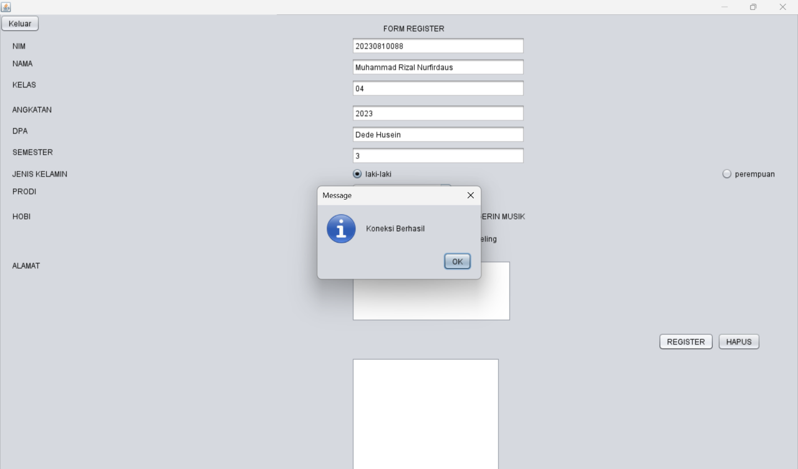

/*

* Click nbfs://nbhost/SystemFileSystem/Templates/Licenses/license-default.txt to change this license

* Click nbfs://nbhost/SystemFileSystem/Templates/GUIForms/JFrame.java to edit this template

*/

import java.sql.ResultSet;

import java.sql.Statement;

import javax.swing.JOptionPane;

import javax.swing.table.DefaultTableModel;

/**

*

* @author Muhammad Rizal Nurfirdaus

*/

public class Form extends javax.swing.JFrame {

Statement st;

ResultSet rs;

koneksi koneksi;

/**

* Creates new form form

*/

public Form() {

initComponents();

koneksi = new koneksi();

load_data();

}

private void simpan_data() {

String nim = jTextField1.getText();

String nama = jTextField2.getText();

String jk = jRadioButton1.isSelected() ? "L" : "P";

String prodi = (String) jComboBox1.getSelectedItem();

String alamat = jTextArea1.getText();

String sql = "INSERT INTO mhs (nim, nama, jk, prodi, alamat) VALUES ('" +

nim + "', '" + nama + "', '" + jk + "', '" + prodi + "', '" + alamat + "')";

try {

st = koneksi.con.createStatement();

st.executeUpdate(sql);

JOptionPane.showMessageDialog(null, "Data berhasil disimpan");

load_data(); // Memuat ulang tabel setelah menyimpan

} catch (Exception e) {

JOptionPane.showMessageDialog(null, "Gagal menyimpan data: " + e.getMessage());

}

}

private void load_data(){

Object header[]={"NIM", "Nama", "Jenis Kelamin", "Prodi", "Alamat"};

DefaultTableModel data = new DefaultTableModel(null, header);

jTable1.setModel(data);

String sql = "SELECT mhs.nim, mhs.nama, mhs.jk, mhs.prodi, mhs.alamat";

try{

st = koneksi.con.createStatement();

rs = st.executeQuery(sql);

while(rs.next()){

String k1 = rs.getString(1);

String k2 = rs.getString(2);

String k3 = rs.getString(3);

String k4 = rs.getString(4);

String k5 = rs.getString(5);

String k[]={k1,k2,k3,k4,k5};

data.addRow(k);

}

}catch(Exception e){

JOptionPane.showMessageDialog(null, e);

}

}

/**

* This method is called from within the constructor to initialize the form.

* WARNING: Do NOT modify this code. The content of this method is always

* regenerated by the Form Editor.

*/

@SuppressWarnings("unchecked")

// <editor-fold defaultstate="collapsed" desc="Generated Code">

private void initComponents() {

buttonGroup = new javax.swing.ButtonGroup();

jPanel1 = new javax.swing.JPanel();

jLabel1 = new javax.swing.JLabel();

jLabel2 = new javax.swing.JLabel();

jLabel3 = new javax.swing.JLabel();

jLabel4 = new javax.swing.JLabel();

jLabel5 = new javax.swing.JLabel();

jLabel6 = new javax.swing.JLabel();

jLabel7 = new javax.swing.JLabel();

jTextField1 = new javax.swing.JTextField();

jTextField2 = new javax.swing.JTextField();

jRadioButton1 = new javax.swing.JRadioButton();

jRadioButton2 = new javax.swing.JRadioButton();

jComboBox1 = new javax.swing.JComboBox<String>();

jScrollPane1 = new javax.swing.JScrollPane();

jTextArea1 = new javax.swing.JTextArea();

Simpan = new javax.swing.JToggleButton();

jScrollPane2 = new javax.swing.JScrollPane();

jTable1 = new javax.swing.JTable();

jLabel8 = new javax.swing.JLabel();

jLabel9 = new javax.swing.JLabel();

jLabel10 = new javax.swing.JLabel();

jLabel11 = new javax.swing.JLabel();

jTextField3 = new javax.swing.JTextField();

jTextField4 = new javax.swing.JTextField();

jTextField5 = new javax.swing.JTextField();

setDefaultCloseOperation(javax.swing.WindowConstants.EXIT_ON_CLOSE);

jLabel1.setText("DATA MAHASISWA");

jLabel2.setText("FORM INPUT DATA");

jLabel3.setText("Nama");

jLabel4.setText("NIM");

jLabel5.setText("Jenis Kelamin");

jLabel6.setText("Prodi");

jLabel7.setText("Alamat");

buttonGroup.add(jRadioButton1);

jRadioButton1.setText("L");

jRadioButton1.addActionListener(new java.awt.event.ActionListener() {

public void actionPerformed(java.awt.event.ActionEvent evt) {

// Define the method here or remove this call if not needed

}

});

buttonGroup.add(jRadioButton2);

jRadioButton2.setText("P");

jComboBox1.setModel(new javax.swing.DefaultComboBoxModel<>(new String[] { "TI", "SI", "DKV", " " }));

jTextArea1.setColumns(20);

jTextArea1.setRows(5);

jScrollPane1.setViewportView(jTextArea1);

Simpan.setText("Simpan");

Simpan.addActionListener(new java.awt.event.ActionListener() {

public void actionPerformed(java.awt.event.ActionEvent evt) {

simpan_data();

}

});

jTable1.setModel(new javax.swing.table.DefaultTableModel(

new Object [][] {

{null, null, null, null, null, null, null},

{null, null, null, null, null, null, null},

{null, null, null, null, null, null, null},

{null, null, null, null, null, null, null},

{null, null, null, null, null, null, null},

{null, null, null, null, null, null, null},

{null, null, null, null, null, null, null},

{null, null, null, null, null, null, null}

},

new String [] {

"Title 1", "Title 2", "Title 3", "Title 4", "Title 5", "Title 6", "Title 7"

}

));

jScrollPane2.setViewportView(jTable1);

jLabel8.setText("DATA MAHASISWA");

jLabel9.setText("Kelas");

jLabel10.setText("Angkatan");

jLabel11.setText("No HP");

javax.swing.GroupLayout jPanel1Layout = new javax.swing.GroupLayout(jPanel1);

jPanel1.setLayout(jPanel1Layout);

jPanel1Layout.setHorizontalGroup(

jPanel1Layout.createParallelGroup(javax.swing.GroupLayout.Alignment.LEADING)

.addGroup(jPanel1Layout.createSequentialGroup()

.addGroup(jPanel1Layout.createParallelGroup(javax.swing.GroupLayout.Alignment.LEADING)

.addGroup(jPanel1Layout.createSequentialGroup()

.addContainerGap()

.addGroup(jPanel1Layout.createParallelGroup(javax.swing.GroupLayout.Alignment.LEADING)

.addComponent(jLabel3)

.addComponent(jLabel6)

.addComponent(jLabel7)

.addComponent(jLabel9)

.addComponent(jLabel10)

.addComponent(jLabel11)

.addComponent(jLabel5)

.addComponent(jLabel4))

.addGap(65, 65, 65)

.addGroup(jPanel1Layout.createParallelGroup(javax.swing.GroupLayout.Alignment.LEADING)

.addGroup(jPanel1Layout.createSequentialGroup()

.addGroup(jPanel1Layout.createParallelGroup(javax.swing.GroupLayout.Alignment.LEADING)

.addComponent(Simpan)

.addGroup(jPanel1Layout.createParallelGroup(javax.swing.GroupLayout.Alignment.LEADING)

.addComponent(jScrollPane1, javax.swing.GroupLayout.Alignment.TRAILING, javax.swing.GroupLayout.PREFERRED_SIZE, javax.swing.GroupLayout.DEFAULT_SIZE, javax.swing.GroupLayout.PREFERRED_SIZE)

.addComponent(jComboBox1, javax.swing.GroupLayout.PREFERRED_SIZE, javax.swing.GroupLayout.DEFAULT_SIZE, javax.swing.GroupLayout.PREFERRED_SIZE))

.addGroup(jPanel1Layout.createSequentialGroup()

.addComponent(jRadioButton1)

.addPreferredGap(javax.swing.LayoutStyle.ComponentPlacement.RELATED)

.addComponent(jRadioButton2))

.addGroup(jPanel1Layout.createParallelGroup(javax.swing.GroupLayout.Alignment.TRAILING, false)

.addComponent(jTextField5, javax.swing.GroupLayout.Alignment.LEADING)

.addComponent(jTextField4, javax.swing.GroupLayout.Alignment.LEADING)

.addComponent(jTextField3, javax.swing.GroupLayout.Alignment.LEADING)

.addComponent(jTextField2, javax.swing.GroupLayout.Alignment.LEADING, javax.swing.GroupLayout.DEFAULT_SIZE, 207, Short.MAX_VALUE)

.addComponent(jTextField1, javax.swing.GroupLayout.Alignment.LEADING, javax.swing.GroupLayout.DEFAULT_SIZE, 207, Short.MAX_VALUE)))

.addGap(18, 18, 18)

.addComponent(jScrollPane2, javax.swing.GroupLayout.PREFERRED_SIZE, 564, javax.swing.GroupLayout.PREFERRED_SIZE))

.addGroup(jPanel1Layout.createSequentialGroup()

.addGap(21, 21, 21)

.addComponent(jLabel2)

.addGap(325, 325, 325)

.addComponent(jLabel8))))

.addGroup(jPanel1Layout.createSequentialGroup()

.addGap(342, 342, 342)

.addComponent(jLabel1)))

.addContainerGap(30, Short.MAX_VALUE))

);

jPanel1Layout.setVerticalGroup(

jPanel1Layout.createParallelGroup(javax.swing.GroupLayout.Alignment.LEADING)

.addGroup(jPanel1Layout.createSequentialGroup()

.addGap(18, 18, 18)

.addComponent(jLabel1)

.addGap(18, 18, 18)

.addGroup(jPanel1Layout.createParallelGroup(javax.swing.GroupLayout.Alignment.BASELINE)

.addComponent(jLabel2)

.addComponent(jLabel8))

.addPreferredGap(javax.swing.LayoutStyle.ComponentPlacement.UNRELATED)

.addGroup(jPanel1Layout.createParallelGroup(javax.swing.GroupLayout.Alignment.LEADING, false)

.addGroup(jPanel1Layout.createSequentialGroup()

.addGroup(jPanel1Layout.createParallelGroup(javax.swing.GroupLayout.Alignment.BASELINE)

.addComponent(jTextField1, javax.swing.GroupLayout.PREFERRED_SIZE, javax.swing.GroupLayout.DEFAULT_SIZE, javax.swing.GroupLayout.PREFERRED_SIZE)

.addComponent(jLabel4))

.addGap(18, 18, 18)

.addGroup(jPanel1Layout.createParallelGroup(javax.swing.GroupLayout.Alignment.BASELINE)

.addComponent(jTextField2, javax.swing.GroupLayout.PREFERRED_SIZE, javax.swing.GroupLayout.DEFAULT_SIZE, javax.swing.GroupLayout.PREFERRED_SIZE)

.addComponent(jLabel3))

.addGap(18, 18, 18)

.addGroup(jPanel1Layout.createParallelGroup(javax.swing.GroupLayout.Alignment.LEADING)

.addComponent(jLabel9)

.addComponent(jTextField3, javax.swing.GroupLayout.PREFERRED_SIZE, javax.swing.GroupLayout.DEFAULT_SIZE, javax.swing.GroupLayout.PREFERRED_SIZE))

.addGap(18, 18, 18)

.addGroup(jPanel1Layout.createParallelGroup(javax.swing.GroupLayout.Alignment.LEADING)

.addComponent(jLabel10)

.addComponent(jTextField4, javax.swing.GroupLayout.PREFERRED_SIZE, javax.swing.GroupLayout.DEFAULT_SIZE, javax.swing.GroupLayout.PREFERRED_SIZE))

.addGap(18, 18, 18)

.addGroup(jPanel1Layout.createParallelGroup(javax.swing.GroupLayout.Alignment.LEADING)

.addComponent(jLabel11)

.addComponent(jTextField5, javax.swing.GroupLayout.PREFERRED_SIZE, javax.swing.GroupLayout.DEFAULT_SIZE, javax.swing.GroupLayout.PREFERRED_SIZE))

.addGap(18, 18, 18)

.addGroup(jPanel1Layout.createParallelGroup(javax.swing.GroupLayout.Alignment.BASELINE)

.addComponent(jLabel5)

.addComponent(jRadioButton1)

.addComponent(jRadioButton2))

.addPreferredGap(javax.swing.LayoutStyle.ComponentPlacement.RELATED, javax.swing.GroupLayout.DEFAULT_SIZE, Short.MAX_VALUE)

.addGroup(jPanel1Layout.createParallelGroup(javax.swing.GroupLayout.Alignment.LEADING)

.addGroup(jPanel1Layout.createSequentialGroup()

.addComponent(jComboBox1, javax.swing.GroupLayout.PREFERRED_SIZE, javax.swing.GroupLayout.DEFAULT_SIZE, javax.swing.GroupLayout.PREFERRED_SIZE)

.addPreferredGap(javax.swing.LayoutStyle.ComponentPlacement.UNRELATED)

.addGroup(jPanel1Layout.createParallelGroup(javax.swing.GroupLayout.Alignment.LEADING)

.addComponent(jScrollPane1, javax.swing.GroupLayout.PREFERRED_SIZE, javax.swing.GroupLayout.DEFAULT_SIZE, javax.swing.GroupLayout.PREFERRED_SIZE)

.addComponent(jLabel7))

.addPreferredGap(javax.swing.LayoutStyle.ComponentPlacement.RELATED)

.addComponent(Simpan))

.addComponent(jLabel6)))

.addComponent(jScrollPane2, javax.swing.GroupLayout.PREFERRED_SIZE, 367, javax.swing.GroupLayout.PREFERRED_SIZE))

.addContainerGap(javax.swing.GroupLayout.DEFAULT_SIZE, Short.MAX_VALUE))

);

javax.swing.GroupLayout layout = new javax.swing.GroupLayout(getContentPane());

getContentPane().setLayout(layout);

layout.setHorizontalGroup(

layout.createParallelGroup(javax.swing.GroupLayout.Alignment.LEADING)

.addComponent(jPanel1, javax.swing.GroupLayout.DEFAULT_SIZE, javax.swing.GroupLayout.DEFAULT_SIZE, Short.MAX_VALUE)

);

layout.setVerticalGroup(

layout.createParallelGroup(javax.swing.GroupLayout.Alignment.LEADING)

.addComponent(jPanel1, javax.swing.GroupLayout.DEFAULT_SIZE, javax.swing.GroupLayout.DEFAULT_SIZE, Short.MAX_VALUE)

);

pack();

}// </editor-fold>

/**

* @param args the command line arguments

*/

public static void main(String args[]) {

/* Set the Nimbus look and feel */

//<editor-fold defaultstate="collapsed" desc=" Look and feel setting code (optional) ">

/* If Nimbus (introduced in Java SE 6) is not available, stay with the default look and feel.

* For details see http://download.oracle.com/javase/tutorial/uiswing/lookandfeel/plaf.html

*/

try {

for (javax.swing.UIManager.LookAndFeelInfo info : javax.swing.UIManager.getInstalledLookAndFeels()) {

if ("Nimbus".equals(info.getName())) {

javax.swing.UIManager.setLookAndFeel(info.getClassName());

break;

}

}

} catch (ClassNotFoundException ex) {

java.util.logging.Logger.getLogger(Form.class.getName()).log(java.util.logging.Level.SEVERE, null, ex);

} catch (InstantiationException ex) {

java.util.logging.Logger.getLogger(Form.class.getName()).log(java.util.logging.Level.SEVERE, null, ex);

} catch (IllegalAccessException ex) {

java.util.logging.Logger.getLogger(Form.class.getName()).log(java.util.logging.Level.SEVERE, null, ex);

} catch (javax.swing.UnsupportedLookAndFeelException ex) {

java.util.logging.Logger.getLogger(Form.class.getName()).log(java.util.logging.Level.SEVERE, null, ex);

}

//</editor-fold>

//</editor-fold>

/* Create and display the Form */

java.awt.EventQueue.invokeLater(new Runnable() {

public void run() {

new Form().setVisible(true);

}

});

}

// Variables declaration - do not modify

private javax.swing.JToggleButton Simpan;

private javax.swing.ButtonGroup buttonGroup;

private javax.swing.JComboBox<String> jComboBox1;

private javax.swing.JLabel jLabel1;

private javax.swing.JLabel jLabel10;

private javax.swing.JLabel jLabel11;

private javax.swing.JLabel jLabel2;

private javax.swing.JLabel jLabel3;

private javax.swing.JLabel jLabel4;

private javax.swing.JLabel jLabel5;

private javax.swing.JLabel jLabel6;

private javax.swing.JLabel jLabel7;

private javax.swing.JLabel jLabel8;

private javax.swing.JLabel jLabel9;

private javax.swing.JPanel jPanel1;

private javax.swing.JRadioButton jRadioButton1;

private javax.swing.JRadioButton jRadioButton2;

private javax.swing.JScrollPane jScrollPane1;

private javax.swing.JScrollPane jScrollPane2;

private javax.swing.JTable jTable1;

private javax.swing.JTextArea jTextArea1;

private javax.swing.JTextField jTextField1;

private javax.swing.JTextField jTextField2;

private javax.swing.JTextField jTextField3;

private javax.swing.JTextField jTextField4;

private javax.swing.JTextField jTextField5;

// End of variables declaration

}  
